A wire is a tuple:

- a source,
- list of input receivers.

For example, consider Fig. <$n:figure:Example1>

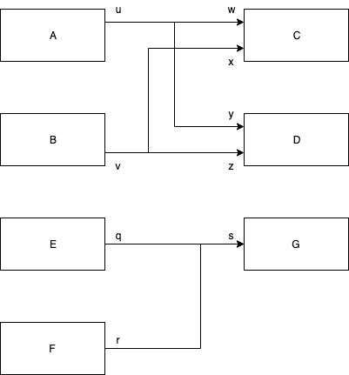
Fig. <$n:figure:Example1> Example 1

This example contains 4 wires.

The wiring list might be expressed as

A.u —> [C.w, D.y]
B.v —> [C.x, D.z]
E.q —> G.s
F.r —> G.s

The sources are A.u, A.b, E.q and F.r.

The receivers are C.w, C.x, D.y, D.z and G.s.

In this example, the first wire has A.u as its source and the list [C.w,D.y] as its list of receivers.

Wires belong to schematics.

A source consists of
- an output pin (which also includes a reference to the sending part)
- a wire, a list of receivers.

A receiver consists of
- an input pin (which also includes a reference to the receiving part).

